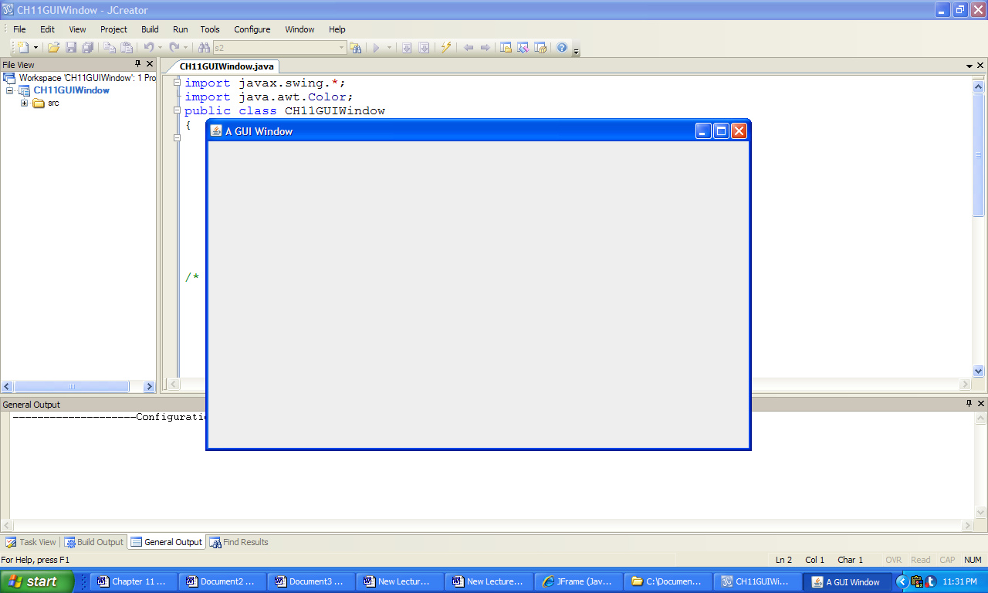

**Figure 11.8 A Program Window.**